|  |  |
| --- | --- |
| Smart weather station  Project Proposal | Abstract  A self-state reporting solar powered weather station with power management which gathers different types of weather data, stores them for future analysis and transmit them periodically to the backend using GPRS.  Kajan 140709U  CS3282 Industrial Computer Engineering Project |

# introduction

Records of daily weather conditions have been kept for 200 years and more, of course, but traditionally have always required a diligent and dedicated human observer to record readings from manual instruments at a fixed time, without fail, every single day. And to analyze the daily data collected over months and years, more painstaking paperwork was called for. Smart Weather Station is a solution to this problem. It is a self-state monitoring and reporting solar powered weather station with power management which gathers different types of weather data, stores them for future analysis and transmit them periodically to the backend using GPRS.

# System functions

* Senses different environmental values.
* Completely solar powered.
* Has full database containing history of the environment (MySQL)
* Periodic data transmission using GPRS to a back-end database.
* Self-contained and monitored for brownouts and power issues.
* Download data to crunch it on the PC
* Can connect to the IOT via Twitter, texting, e-mail and Wi-Fi.

# Skills I will acquire by doing this project

* Hand on experience on building a solar powered system. Knowledge about limitations and advantages of Solar powered system.
* Gathering data to analyze system performance.
* Shutting down and starting up small computers on solar power.
* Periodic data transmission to backend database over GPRS.
* Power management in embedded devices.
* Connect embedded device to IOT environment.

# Deleiverables

* Standalone battery powered device to act as a weather station with pluggable-modules including rain gauge, temperature, humidity, wind gauge.
* Data should be stored in an SD card and also transmitted periodically using GPRS to a back-end database.
* The device should have power management.

# rESEARCH

## Design Considerations for Solar Energy Harvesting Wireless Embedded Systems

Solar energy supply is highly time varying and may not always be sufficient to power the embedded system. Harvesting components, such as solar panels, and energy storage elements, such as batteries or ultra-capacitors, have different voltage-current characteristics, which must be matched to each other as well as the energy requirements of the system to maximize harvesting efficiency. Further, battery non-idealities, such as self-discharge and round trip efficiency, directly affect energy usage and storage decisions. The ability of the system to modulate its power consumption by selectively deactivating its sub-components also impacts the overall power management architecture [[1]](http://ieeexplore.ieee.org/document/1440973/).

Listed below are important tasks to be done when designing a solar charge controller [[2]](http://www.instructables.com/id/ARDUINO-SOLAR-CHARGE-CONTROLLER-Version-20/).

Auto charge set point according to the battery voltage.

Lightning protection.

Reverse current flow protection.

Short circuit and over load protection.

Temperature compensation for charging.

## $\frac{C}{10}$ Rule

Current equal to 10-13% of the battery bank's Ah capacity is an optimum rate to charge the battery [[3]](http://forum.solar-electric.com/discussion/9809/c-8-c-10-c-20-battery-charging-rate).

Suppose we have a 2xAA-sized 1300 mAh battery pack that is raged at 1.2 volts per cell. With cells in series, our pack outputs 2.4 volts and 1300 mAh.

Here capacity $C = 1300 mAh$

$C/{10}=130 mAh$

So, to charge the above battery pack we need a higher voltage (2.4 to 3 V) with a maximum current of 130 mAh.

As per $C/{10}$ rule it requires 16 hours to fully charge the battery pack.

If the current is higher than 130 mAh then of course the battery will charge faster but the battery will reduce.

As I am preparing to build a long lasting smart weather station I will stick with $C/{10}$ rule.

## Choosing the right solar panel

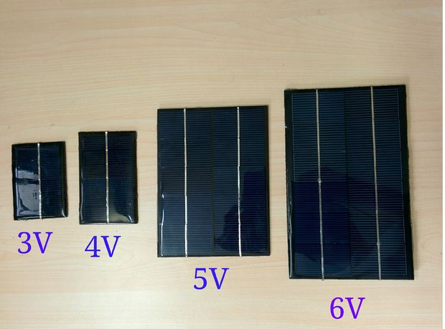The main source for powering the sensor module is solar panel. So, it must be able to provide current for powering the Arduino as well as current to charge the battery pack during the day. As per my research it is the most challenging part.

Some guidelines I learnt from [[4]](http://www.instructables.com/id/SOLAR-POWERED-ARDUINO-WEATHER-STATION/step3/How-to-Choose-the-right-solar-panel/) .

Voltage: 1.5 times the battery pack voltage.

Current: Current taken by the Arduino + current for charging)

Example:

A battery pack is made of 2 AA Ni Mh battery.

Battery voltage = 1.2 x 2= 2.4V

So, required voltage for solar panel =2.4 x 1.5 = 3.6V

By taking some margin we can choose a 4V solar panel for it.

The sensor module along with Arduino taking 100mAh current.

Battery capacity is 1300mAh

C/10 = 130mAh

Solar panel have to provide current 100mAh for Arduino along with a current not more than 130mAh.

Let’s take 100 mAh for charging the battery

Total current required = 100+100=200mAh

From the above calculation, it is clear that we need a solar panel of 4V and 200mAh.

## Problems arising while reading multiple analog inputs.

In my project, I have to read multiple analog inputs. Also, I am preferring Arduino Uno as it is low power consuming board. This [[5]](https://forum.arduino.cc/index.php?topic=54976.0) forum gave me some idea about possible reading errors that could occur while reading multiple analog inputs and how I could avoid them by reading twice, with a small delay after each read (10 ms is good).

# POC Plan

I am planning to proof the concept by doing feasible study in below categories.

## core Idea.

Here, I will come up with a possible solution to implement the required deliverables by analyzing available feasible technologies. This part will also contain a simulation done using fritzing [[6]](http://fritzing.org/home/).

## Components analyzis.

Here, I will list the necessary component list and their availability in Sri Lanka. Components price will also be considered.

## Power analyzis.

This section will focus on mapping required average power and solar produced average power based on the datasheet values.

## Required time.

This will basically a time line consisting of work breakdowns using Microsoft Project 2016.

# References

[1] Design considerations for solar energy harvesting wireless embedded systems - IEEE Xplore document (2017) Available at: http://ieeexplore.ieee.org/document/1440973/ (Accessed: 17 February 2017).

[2] 168, deba ARDUINO SOLAR CHARGE CONTROLLER (version 2.0). Available at: http://www.instructables.com/id/ARDUINO-SOLAR-CHARGE-CONTROLLER-Version-20/ (Accessed: 17 February 2017).

[3] C/8, C/10, C/20 battery charging rate??? (2011) Available at: http://forum.solar-electric.com/discussion/9809/c-8-c-10-c-20-battery-charging-rate (Accessed: 18 February 2017).

[4] 168, deba How to choose the right solar panel. Available at: http://www.instructables.com/id/SOLAR-POWERED-ARDUINO-WEATHER-STATION/step3/How-to-Choose-the-right-solar-panel/ (Accessed: 18 February 2017).

[5] AG, A. (2017) Reading multiple analog inputs. Available at: https://forum.arduino.cc/index.php?topic=54976.0 (Accessed: 20 February 2017).

[6] Fritzing Available at: http://fritzing.org/home/ (Accessed: 20 February 2017).